ABLE FORMAT WITH INSTRUCTOR AND STUDENT TEXT
Authentic curriculum undergraduate research experimentation to learn about the effects of septicemia on cardiac function: frog and larval Drosophila models

Jate Bernard¹, Melody Danley¹, Rebecca M. Krall², Katherine A. Sharp² and Robin L. Cooper¹

¹675 Rose St., Department of Biology, University of Kentucky, Lexington, KY 40506-0225 USA
²Rm 105 Taylor Education Bldg, 597 S. Upper St, Department of STEM Education, University of Kentucky, Lexington, KY 40506-0001, USA
(jatebernard@gmail.com; mlda227@uky.edu; Rebecca.krall@uky.edu; katherinesharp@uky.edu; RLCOOP1@uky.edu)

Abstract
Our educational module offers a new approach to studying cardiovascular function by utilizing a high-interest topic, effects of endotoxin-related septicemia (Lipopolysaccharides, LPS) from gram negative bacteria. Research on LPS is abundant in the area of neuroscience and neuromuscular junction activity. However, little is known on its effects in cardiac tissue. We have developed and piloted several hands-on laboratory exercises including simple heartbeat counts (HR) to more advanced electrical recording of diastolic and systolic periods with in-situ hearts. Furthermore, the laboratory module is highly flexible for virtual or in-person completion: we have adapted this module to both the frog and larval Drosophila melanogaster. The flexibility of this module also makes it adaptive to different classroom and laboratory settings, including CUREs courses. Utilization of comparative laboratory exercises combined with primary literature reviews can be used to foster a deeper understanding of the diversity of cardiovascular mechanisms possible among animals. Finally, this module contains pedagogical support for instructors interested in open inquiry and active learning approaches.

Keywords: problem-based learning, cardiovascular module, septicemia, health, physiology

Introduction
Traditional undergraduate anatomy and physiology courses follow standard protocols for laboratory experimentation, partly because of the commercialization of student equipment and pre-packaged software. As a result, much student laboratory coursework utilizes similar experiments across colleges and universities, such as measuring lung volumes as a human respiration lab or measuring properties of the frog gastrocnemius muscle contractions as a skeletal muscle lab. While such laboratory exercises have been shown to increase the students’ understanding in factual concepts, chronic reuse of the same pre-packaged lab exercises raises many concerns, including reduced academic diversity, loss of critical thinking opportunities, transfer of completed worksheets directly among peers at the same institution or indirectly from other institutions (e.g. downloading completed reports from internet websites), and lack of student interest and motivation to complete the work (Henige, K., 2011: Esparza et al., 2020).

To increase student interest and motivation, foster critical thinking skills, and promote academic diversity and independence of student work, there is strong interest to develop effective course-based authentic undergraduate research experiences, or ACUREs (Bakshi, et al., 2016; Linn, 2015). Effective ACUREs also have the potential to empower students to communicate novel scientific findings to the scientific community, thus helping the student develop scientific communication skills as well as a sense of scientific identity (Staub et al. 2016; Esparza et al., 2020). Furthermore, there are now increased numbers of journals which promote peer-reviewed undergraduate research (e.g. Malloy et al., 2017). Such journals as IMPULSE (The Premier Undergraduate Neuroscience Journal. https://impulse.appstate.edu/issues/2017) and American Journal of Undergraduate Research (AJUR) are overseen by faculty with the emphasis on publications by undergraduates.

Development and implementation of ACURES frequently begins with identification of unique research opportunities that can be scaled up for use in laboratory-based courses (e.g. Makarevitch et al., 2015; Stanback et al., 2019; Staub et al., 2016; Swanson et al. 2016; Thenappan et al., 2019). Modern ACUREs are different from traditional internship-like research experiences, because the experienced mentors (faculty, post docs, and graduate students) assist larger groups of students through a series of modules and/or assignments based on experimentation where the results are not yet known to the scientific community. This approach can be limiting however, since the “straight from the research lab” approach often requires identification of suitable research topics, development of an entirely new course and student-friendly procedures, a large investment of the mentor’s time, and/or purchase of new equipment and materials. However, what if the traditional lab exercises and equipment could be modified without the need for development of new courses, changes to program curriculum, or purchase of new equipment? In this paper, we describe the development and implementation of a flexible mini-ACUREs within a pre-existing upper division animal physiology course, that utilized pre-existing equipment, standardized lab procedures and readily available software packages. The novelty of the project is the use of experimental treatments with unknown effects within the context of a traditional lab exercise: the effects of lipopolysaccharides (LPS) from gram-negative bacteria on the contractile properties of frog and Drosophila hearts. Further, new findings are of interest to the scientific community, since LPS is known to trigger illness in humans such as septicemia.

Student interest can be peaked by the use and careful selection of such novel treatments. As students explore the scientific literature before and/or after the experiment, they will need to acquire an understanding of the anatomy of the heart (frog, human, and/or Drosophila models), as well as the mechanism by which the cardiac pacemaker cells, cardiac contractile cells, autonomic nervous system, and endocrine systems work together to accomplish the goal of synchronized, rhythmic contractions. Students can be directed to consider experimental design elements such as appropriate model organisms, treatment concentrations, exposure location and method, as well as appropriate response variables to record. Efforts to explain the results can help reinforce concepts covered in the lecture portion of the course. For example, our module could be used to support cardiac, neural, and homeostatic concepts in an animal physiology course. Finally, as the results must be explained de novo each semester, students are provided an opportunity to diversify their explanations and utilize critical thinking skills. As with other ACUREs, small changes to experimental design can be used to help sustain the “authentic” aspect of the ACUREs between semesters.

Student Outline
Objectives
Students will learn:
- How the frog heart is arranged anatomically compared to mammalian hearts.
- The general anatomy of the cardiovascular system, relevant subsystems, and practical health-related terms associated with the cardiovascular system.
- How the heart generates electrical activity and conducts electrical activity.
- Types of septicemia and how they arise.
- The effects of bacterial septicemia on the physiology of the body and general immune response.
- The potential mechanism of action of LPS on heart rate.
- Comparative cardiac physiology and immune response with insects and mammals.

Introduction
Imagine what would happen physiologically if your heart suddenly sped up, slowed down, or started beating erratically? To understand the physiological consequences of an irregular heartbeat, one needs to understand the various roles of the cardiovascular system, heart anatomy, and peripheral circulation. But how can we do this in a living person? One approach to learning more about the human heart and cardiovascular system is to use a different model organism with a similar physiological system. For example, frogs have long been used as model organisms to study the human cardiovascular system and heart because, like humans, frogs have closed circulatory systems with multi-chambered myogenic hearts. Another approach is the study the same system among many different animals so that different strategies to solving the same issue can be better understood. For example, many researchers study properties of the human heart by conducting experiments on insects, such as Drosophila.

We can use larval Drosophila and frog hearts to learn about concepts relating to human hearts. For example, what conditions might trigger the heart of Drosophila, frog or human to beat with an irregular pattern? Conditions might originate externally, such as exposing the organism to extreme environmental conditions or being threatened by a large predator. Conditions might also originate internally through malnutrition or toxins released by cells. Furthermore, the duration of the irregular heart beat may be transient, chronic, or both. For example, suppose a man is bitten on the hand by an aggressive dog. As the dog’s teeth bite down and penetrate the man’s skin, the man’s heart suddenly speeds up in his chest. This occurs because the man’s nervous system activates fight or flight responses that increase sympathetic signaling to the sinoatrial node, or patch of pacemaker cells in the right atrium that controls his heart rate. This ability to change the rate of contractions in the heart was first explored more than 150 years ago when it was noted that the sinoatrial node (SA node) was the master pacemaker of the mammalian heart (Purkinje 1845). As our understanding of the pacemaker activity increased, scientists discovered that the SA node conducted signals down to the atrioventricular node, the Bundles of His, and Purkinje fibers. Contraction events then followed the rhythmic, synchronized electrical signals (Purkinje 1845; Ono et al., 2009). Comparison of experimental results from different model organisms revealed that other vertebrates had similar types of cardiac pumps (Victor & Nayak, 2000; Anderson, et al., 2018). Comparative studies in the circulatory system of invertebrates has shown additional similarities across vastly different animal lineages (Monahan-Earley et al., 2013; Rizki T (1978). For example, the heart tube of Drosophila has been of particular interest due to the genetic amenability and its usefulness when modeling human disorders and disease states (Lehmacher et al. 2012; Gu and Singh 1995; Akasaka and Ocorr 2009; Bodmer 1995; Cripps and Olson 2002; Rotstein and Paululat, 2016; Wessells and Bodmer 2004; Nishimura et al. 2011; Na et al. 2013)
The increase to the heart rate of the man bit by the dog was both predictable and normal, as his body prepares him to defend himself or flee from the threat. For example, in the man bitten by the dog, suppose the saliva from the dog’s mouth was forced through the protective top layers of the skin and down into the underlying dermis. Mixed in the dog saliva was toxin producing bacteria that was introduced into the man’s body. The way this new threat will affect the man’s body and heart is less predictable.

The immune system helps to defend the body from foreign organisms such as bacteria, viruses, and parasites. However, when the body is overloaded with foreign organisms, the immune system’s ability to defend itself can become compromised. For example, septicemia is a type of blood poisoning that results when a bacterial infection moves into the bloodstream and begins circulating throughout the body. Different types of bacteria result in varied immune responses within organisms, which is partly due to the different types of endotoxins released from bacteria. Strains of gram-negative bacteria, such as Escherichia coli, Pseudomonas aeruginosa, and Serratia marcescens, are commonly associated with septicemia in invertebrates and humans (Lorenzon et al., 2002; Pien et al., 2010; Carl et al., 2014; Kim et al., 2015; Palavutitotai et al., 2018). In the case of the man with the dog bite, suppose the site of injury became infected with gram negative bacteria that began producing and releasing endotoxins into the surrounding tissues. At first, the site of injury may have looked like any other cut or scrape, with a scab, redness and swelling. The man may have been unaware that lurking at that site of infection there was an endotoxin building up. If too much of the endotoxins accumulate and begins entering the bloodstream, they could compromise the ability of his heart to function normally.
Release of endotoxins into a person’s body, particularly lipopolysaccharides (LPS) from gram-negative bacteria, triggers the immune system to respond in several ways. First, immune cells such as macrophages and T cells release chemicals known as cytokines. Cytokines are chemical messengers that are released by cells at the site of injury to recruit more immune cells to move towards that location. However, cytokines are also linked to triggering abnormal neural and cardiac function which can be harmful to the host (Eidelman et al., 1996; Wilson and Young, 2003; Friedrich et al., 2015; Tong and Zhou, 2017). High levels of cytokines in mammalian sepsis cases have been correlated with the degradation of skeletal muscles (Al-Nassan and Fujino, 2018). High levels of cytokines have also been shown to impair cardiac function by triggering muscle atrophy and electrical abnormalities (Cimolai et al., 2015; Gao et al., 2015; Liu et al., 2017; Shashikumar et al., 2017; Walley 2018; Wang et al., 2019). Thus, during infection, the bacterial endotoxins often act indirectly on remote tissues (such as the heart) by triggering release of cytokines.
Endotoxins such as LPS may also act directly on the host tissues to produce physiological changes in the host tissues’s function. For example, it is known that LPS binds to a Toll-like receptor 4 (TLR4) known as the CD14/TLR4/MD2 receptor complex in mammals (Yoshida et al., 1996; Steiner, 2004). These receptors are conserved from insects to mammals in most all tissues examined (Levin and Malik, 2017). More recent studies have discovered that unlike mammals, toll-like receptors in Drosophila melanogaster do not appear to mediate the immune response. Instead, the immune response in Drosophila melanogaster appears to be mediated by the Immune deficiency (Imd) signaling pathway (Coscia et al., 2011; Loker et al., 2004; see review by Kleino and Silverman, 2014).
Recently, LPS has been examined for direct effects on the larval heart of Drosophila melanogaster and medicinal blow fly (Phaenicia sericata) in a dose-dependent manner (Anyagaligbo et al., 2019). However, responses varied between these two species of insects to the same type of LPS (Anyagaligbo et al., 2019). The effects of direct application of LPS on the frog heart has not yet been investigated. This brings us to our experimental questions:
- Does LPS act directly on cardiac tissue to change the heart rate of an organism?
- Is the effect of LPS on the cardiac tissue similar among different organisms?

This module is divided into two main experimental procedures. One involves examining the effect of exposure to LPS on frog heats to determine if there is an acute effect on the heart rate. The second and more challenging activity is to determine if there is any effect by LPS exposure on the heart rate in larval Drosophila. The experimental exercises will be conducted following the protocol below. After the experimentation is completed, then the two lesson assignments can be completed and turned in along with the laboratory report.
Take home assignments to be turned in:
Lesson 1: frog and human
1. Draw the 3 chambered frog heart.
2. Draw the 4 chambered mammalian heart.
3. On the two hearts above label the chambers, septum, and list as well as draw on the heart the components for the electrical flow.
4. On the mammalian heart diagram, list out the average pacemaker rate for the various regions independent of each other.
5. Draw on the human heart where the parasympathetic and sympathetic innervation occurs and list where the neurons (part of the CNS) where the cell bodies reside.
6. Label on the frog and human heart (make new drawings) the direction of blood flow through the heart.
7. Diagram what is assumed to be the ionic regulation of a pacemaker cell in the mammalian heart.
8. Diagram the cellular process for cardiac muscle contraction beginning with electrical depolarization of the cell.
9. What is known to date in how mechanistically LPS might be directly altering the heartbeat?
Lesson 2: Drosophila
1. Draw the heart tube location within a larva of a Drosophila. Also, label if located on the dorsal or ventral side of the animal and associated tracheal tubes for help in locating the heart tube.
2. Draw where hemolymph will enter and how it flows through the heart tube, as well as the direction of flow. Label the values associated with the heart tube.
3. Label which part of the heart is considered the true heart as compared to the aorta of the heart tube. Label where the hemolymph leaves the heart tube out to the body cavity.
4. If the heart tube is cut between the true heart and aorta do the two parts beat at different rates? Does a human heartbeat at different rates in the atria and ventricle if the AV node conduction is blocked to the Bundle of HIS?
5. In the larval heart neurally innervated? Can hormones or compounds such as serotonin alter heart rate and, if so, does it increase or decrease the rate?
6. Does temperature alter the heart rate in larval Drosophila? If so, does it increase or decrease at colder environmental temperatures?
Discussion
In these exercises, one may have recorded heart rate in a frog and/or a larva of a fruit fly and applied a compound. Specifically for this module, a form of LPS to examine the direct action on cardiac activity. Understanding the general anatomy of the heart among different animals illustrates the generalities, but also the differences. In addressing how a whole tissue functions, one is driven to understanding the function of individual cells.
As one general knows, a heart is necessary to circulate hemolymph or blood in a body from an insect to a mammal. However, there are other aspects of the circulatory system such as circulating hormones, delivery of nutrients to cells, transport oxygen and carbon dioxide (.i.e., HCO3-) as well as help the body rid itself of waste products. The circulatory system also promotes lymph flow in animals with a lymphatic system. In vertebrates, the lymphatic system is important in aiding the body in its immune defense. Interestingly, as compared to mammals, the developing embryo of Drosophila can survive and even grow without the heart tube, as demonstrated in the altered gene expression of Tinman (Bodmer, 1993). Whereas there are similarities in the heart of fruit flies to humans (Rotstein and Paululat, 2016) the differences in the function of the circulatory systems is that gas transport of oxygenation occurs primarily through a tracheal system directly associated with tissues and the circulation is open which results in all the tissues and cells being directly bathed by the hemolymph. However, the central and peripheral nervous system does have a glial barrier. Like mammals, cells and components within the hemolymph can rapidly bind to foreign substances to aggregate the matter and provide an immune response. However, how endotoxins, such as LPS, influence tissue and cellular function is still an active area of investigation (Anyagaligbo et al., 2019; Cooper et al., 2019; Coscia et al., 2011; Istas et al., 2019; Loker et al., 2004; see review by Kleino and Silverman, 2014).
These laboratory exercises bring awareness to the comparative investigations necessary to better understand how endotoxins, such as LPS, can have an influence directly on cardiac function. The ability to examine many other forms of LPS and associated endotoxins that gram negative bacteria are known to release, such as repeats-in-toxin (RTX; Linhartová et al., 2010), can also be screened using the protocols established herein.

Protocol
Safety and initial set up
Participants need to wear lab coats and gloves for these experiments. Do not rub your face or eyes with your gloves. The LPS used is hazardous to humans so care needs to be taken when weighing it out. The compounds will be in saline to avoid powder from being airborne. Dispose of waste saline with chemicals in waste beakers for the lab personalpersonnel to dispose of properly.
Frog heart
The frogs will be deemed unconscious and double pithed (brain and spinal cord) by the lab staff. The frogs will be placed in a dissection dish for participants to expose the heart to compounds for recordings of the heartbeat. The general procedures for dissection to expose the heart of frogs and set up are readily obtained on the internet and various comparative physiology laboratory manuals. We are following the general procedure supplied by ADI Instruments which accompanies the software package (CHART version 8.0) used for recording the heartbeat with the purchased force transducers from ADI Instruments. The protocol supplied by ADI was modified for this particular laboratory exercise.
Force transducer
In these experiments, one can record the rate only with the force transducer or record both a force of contraction and the rate. The force transducer captures the responses electronically, allows one to store the files, and complete the analysis after experimentation. If the force of contraction is to be obtained, then the force transducer needs to be calibrated prior to beginning the experiments. This is obtained by the following steps:

Calibrate force transducer
1. Turn on the Powerlab analog to digital (AD) equipment. Open the software Lab Chart and select “Frog Heart Settings”.
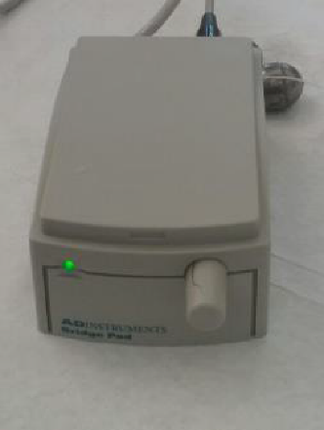
Figure 1: Bridge Pod to be used with hardware and software for the ADI force transducers.
2. Next, your station will have one of the two different force bridge pods. It will have either a manual bridge pod, or a newer digital bridge amp. If your station contains a bridge pod (Figure 1), continue to step 3 below. If your station does not contain a bridge pod, skip to step 4.
3. For stations with a Bridge Pod only: Click on Channel 1, over on the right side of your screen, then select Bridge Pod from the pop-up menu. Observe the signal (Figure 2) in the dialog. Zero this signal by turning the knob on the front of the Bridge Pod. Click OK when done.

4. Next, you will need to calibrate your force transducer so that it records responses in force (Newtons) and not the default value of mV.
5. Obtain a set of weights pre-hung on a fishing swivel. Use a digital scale to measure the mass (g) of the weights.
6. Next, hang the weights from the force transducer. Wait for them to stop swinging.
7. Next, you will need to adjust the sampling time. Click the Set-up tab at the top of the screen. From the drop-down menu, click Sampling. Adjust the sampling time to 20 sec. Then close the window.
8. Click the start button to begin the recording. While the recording is still running, carefully lift the weights off the force transducer so you will have a “with weights” and “without weights” area in the recording. It is probably easiest to lift the weights up so they are no longer pulling down on the force transducer, without unhooking them. Click STOP to end the recording. If needed, repeat the recording until both areas of the recording are clearly visible (see Figure 3 for an example).
9. Once the recording with the weights has been completed, use the mouse to click-and-drag (highlight) the region of the trace that contains both the “with weights” and “without weight” recording.

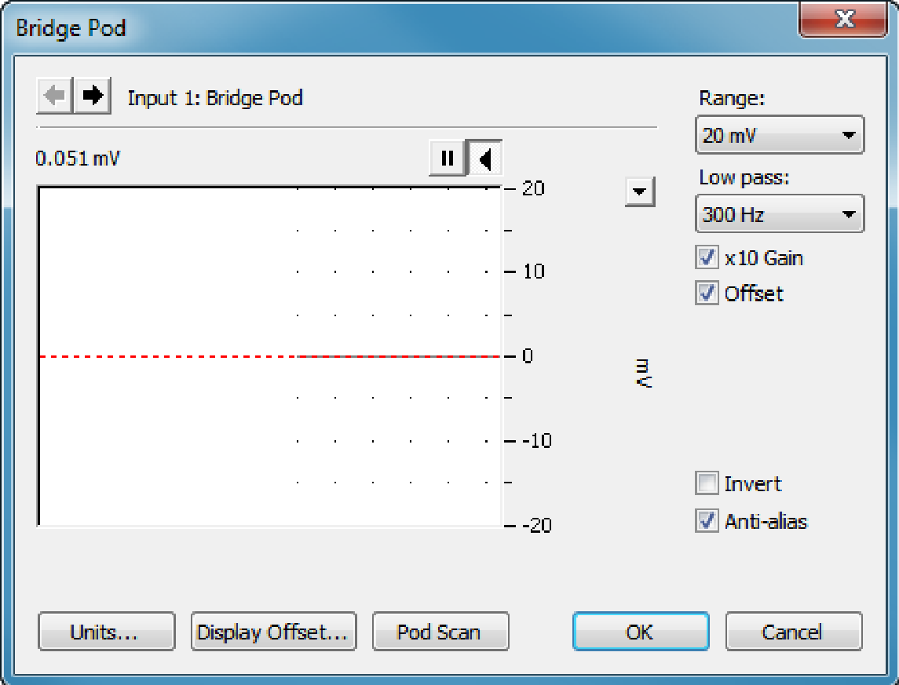
Figure 2: Bridge Pod Dialog (Image taken from ADI protocol)

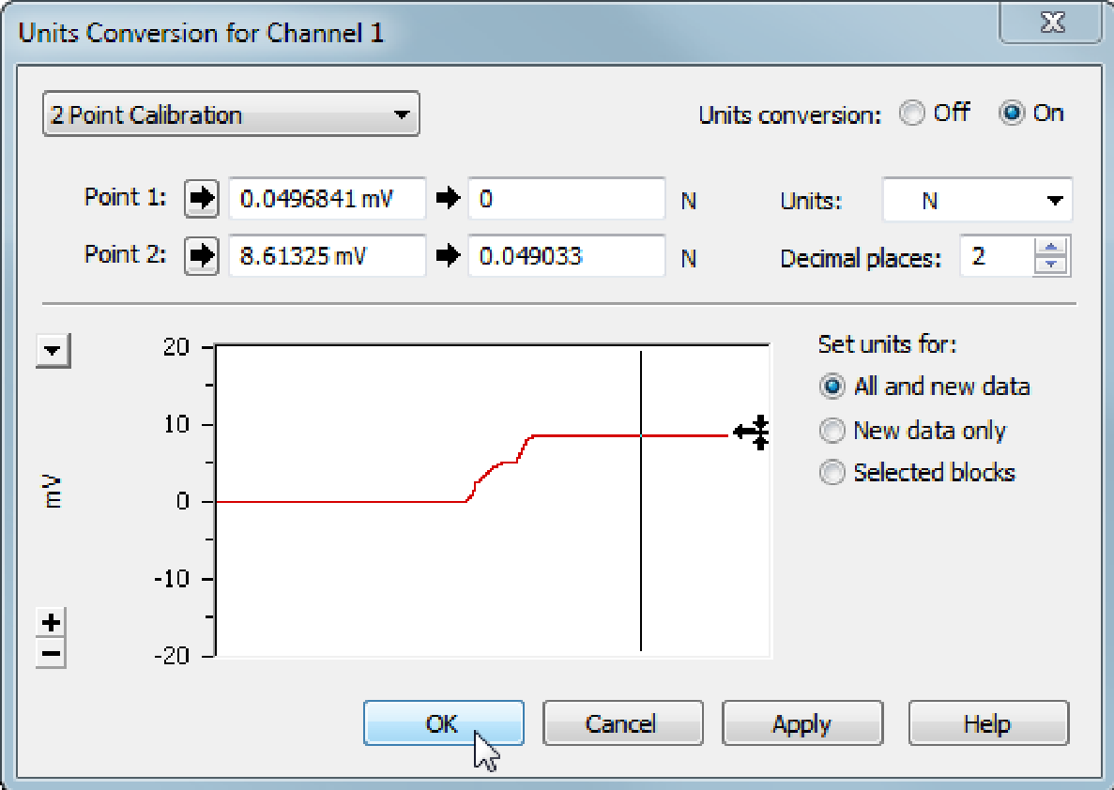
Figure 3: Units Conversion Dialog (Image taken from ADI protocol)

10. Select Units Conversion from the Channel 1 pop-up menu (Figure 3 above).
11. From the pop-up window, click in the box next to “Point 1” and use the mouse to double click on an area of the trace showing the “without weight” recording. Enter zero for the corresponding Newtons (N).
12. Next, click in the box next to “Point 2” and use the mouse to double click on an area of the trace showing the “with weight” recording. Enter the desired unit value in Newtons (N) for the second point. Use the equation below to determine the mass of the weights into Newtons:

Force (N)= (mass in grams)/1000) X 9.80665

Recording the defections on the force transducer to obtain a heart rate
1. The frog needs to be anchored well to the inside of a deep dissection dish to allow saline to be applied to the heart throughout the experiment. The dish may be a wax dish or an elastomer coated dish which allows strong dissection pins to hold the frog in place (Figure 4).
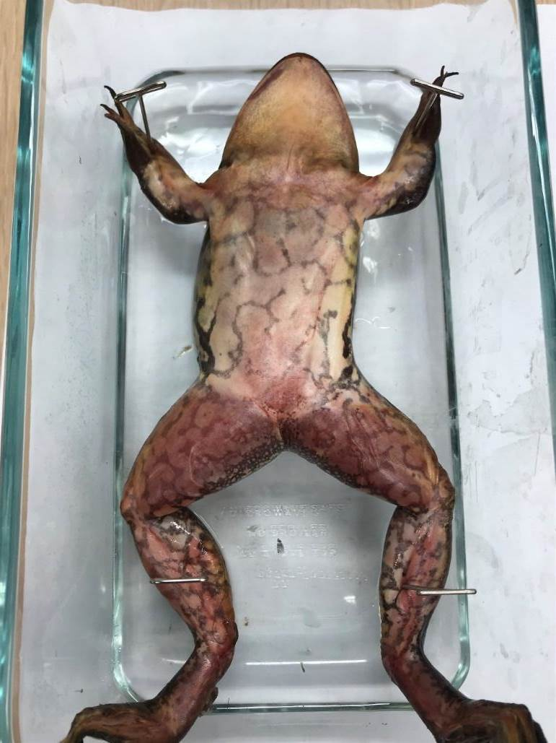
Figure 4: Frog anchored to the dissecting dish

2. To expose the heart and have it beat for a prolonged length of time, you do not want to cut the arteries or large veins. There will be some bleeding while cutting the skin. Do not cut too deep just enough to get through the skin. First make a longitudinal incision as shown in Figure 5A-D. Then with tweezers pick up the skin at the cut and then make a lateral incision to the right and repeat to the left. The lateral incisions are about the mid-length of the abdomen below the heart.

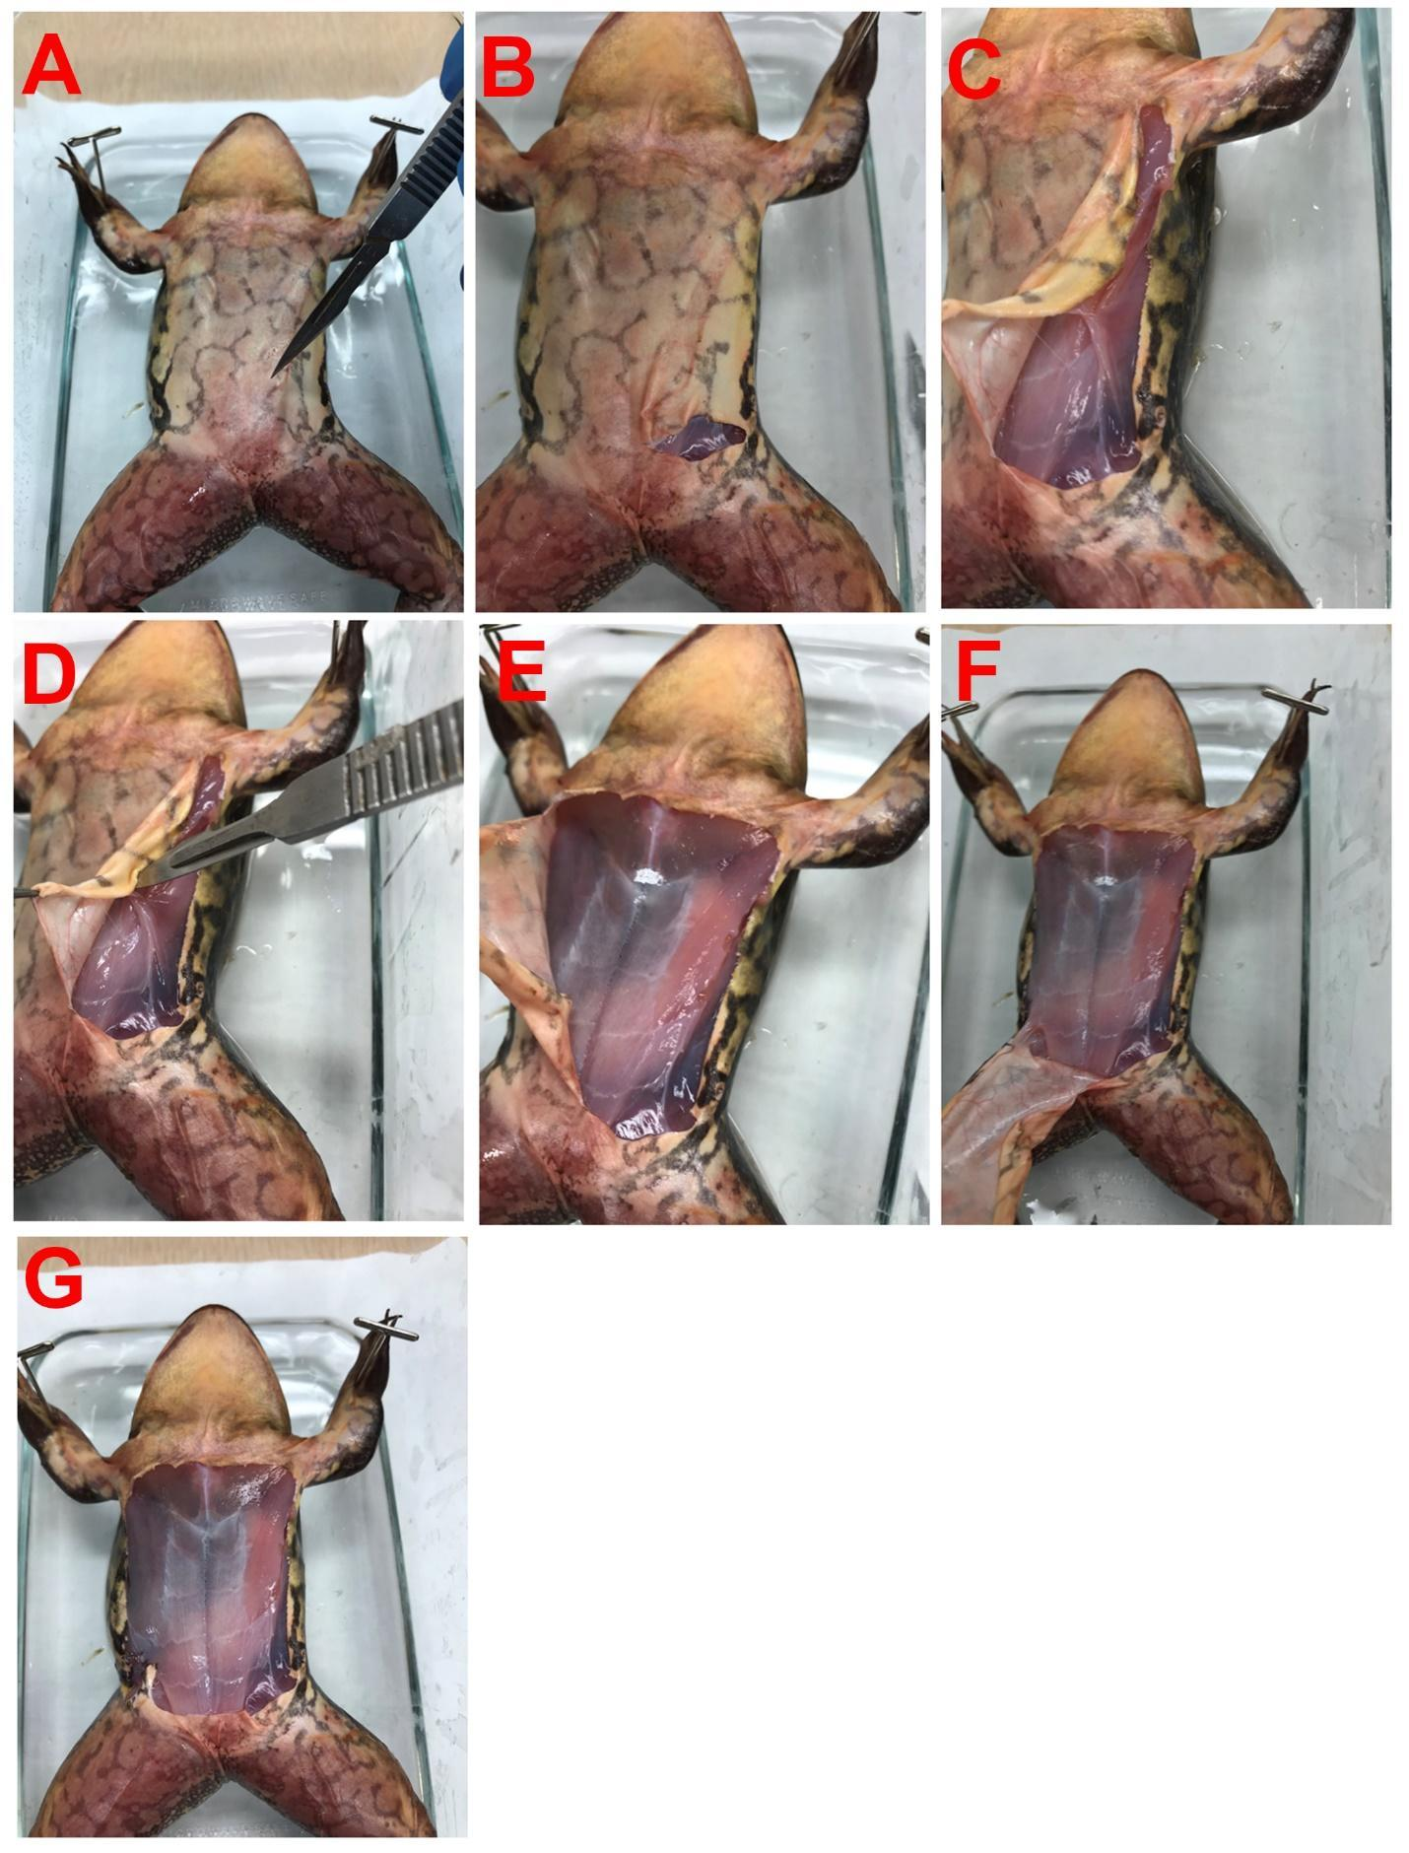
Figure 5: A series of cuts to remove the skin and to expose the location of the heart. Note connective tissue needs to be cut to lift off the skin.

3. When lifting the skin to the lateral side it can be pinned to the dissection dish. The sternum should now be visible(Figure 5E). The sternum can now be cut away with scissors which will open the thoracic cavity containing the heart (Figure 6). The physiological frog Ringer saline should be applied to the heart and the heart should be kept moist at all times with saline.

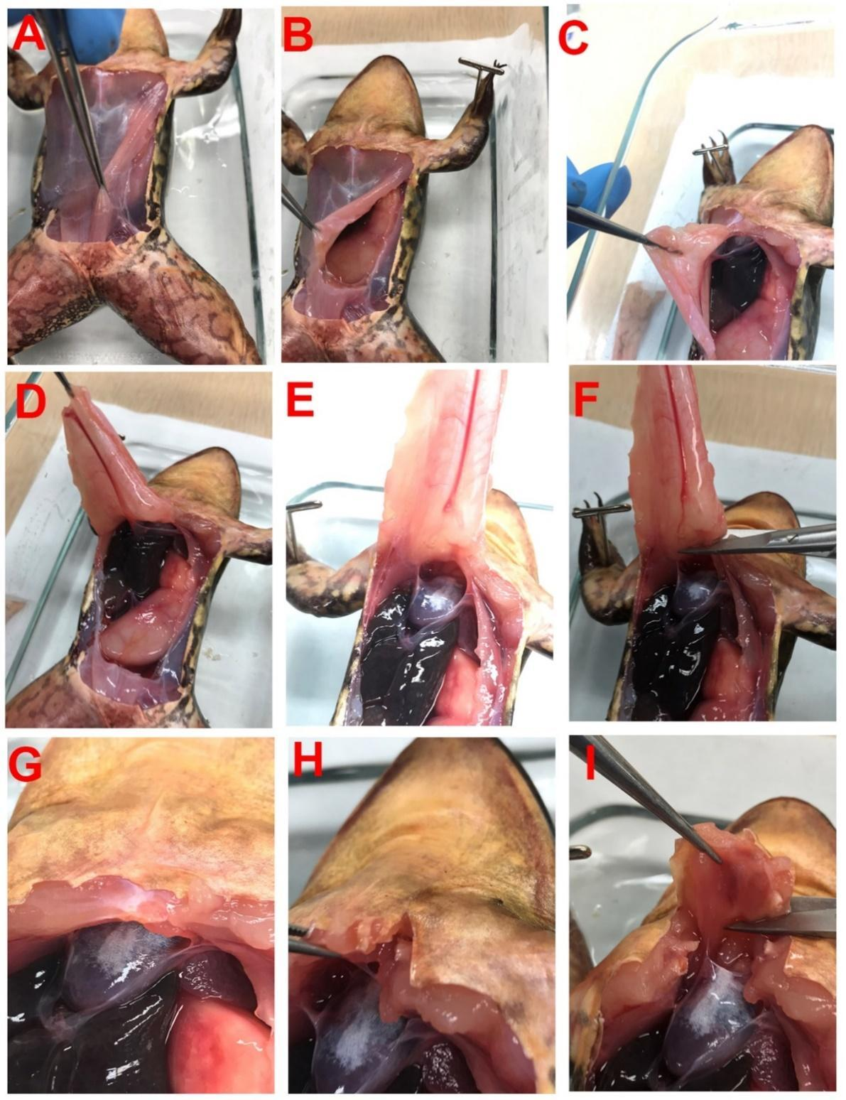
Figure 6: To expose the heart, the abdominal muscles and sternum need to be removed. After removing the abdominal muscles (A through G), the sternum can be isolated by cutting on each side and lifting to be cut away with scissors (H and I). The thoracic cavity containing the heart is now exposed.

4. The pericardial sac needs to be removed (Figure 7). This next step needs fine care as not to nick the heat with the scissors or scalpel. With tweezers pick up a section of the pericardium and cut it away to fully expose the apex of the heart (i.e., the tip of the ventricle).

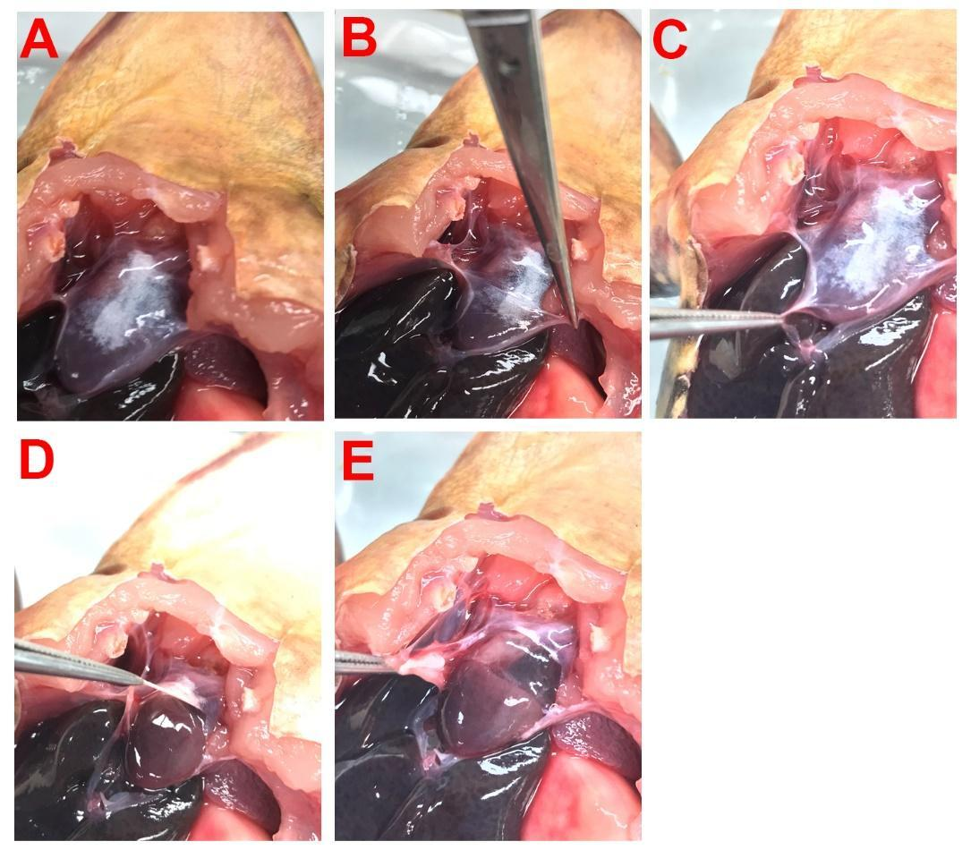

Figure 7: The pericardium needs to be teased away from the heart and cut away to fully expose the apex of the heart (i.e., the tip of the ventricle). Follow A through E steps as shown.

5. To now connect the heart to the force transducer, it is best to maintain the heart in the natural position as best as possible. This requires one to use the clay or some substance which is not slippery. Surgical wax works the best. Hook the very tip of the apex of the heart trying not to go through the ventricle chamber of the heart (Figure 8). Then, one can tilt the heart from itself and the dish with Styrofoam or wax. Tilt the dissecting dish so the heart is almost a 45-degree angle (Figure 8).

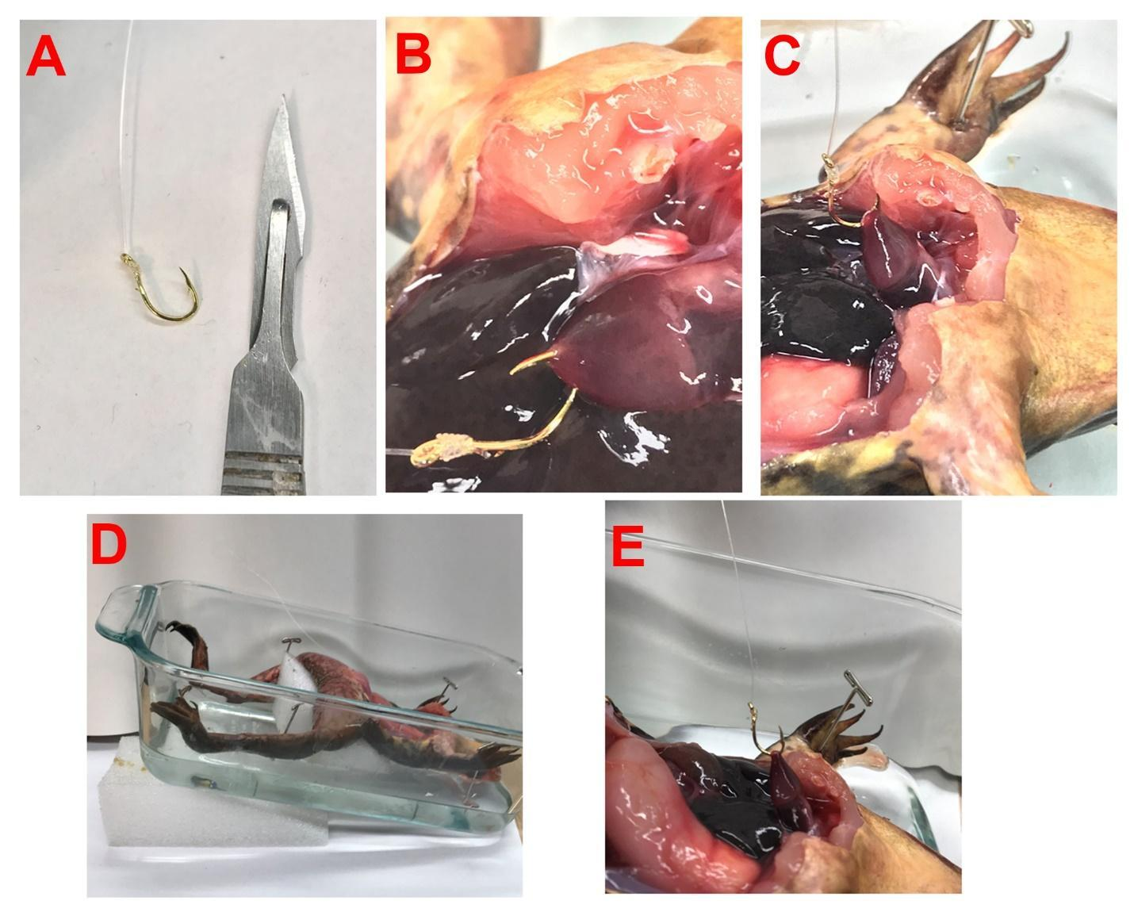
Figure 8: The fishhook is shown next to a scalpel for size (A). Piercing the apex with the hook as shown in B. Slanting the frog and the dish to provide an alignment of the heart with the pull on the transducer (D and E).

6. Now with the other end of the monofilament thread the hole on the force transducer and tie off the line. The monofilament line should be as short as possible (around 5-10 centimeters) from the heart to the Force Transducer.

7. To adjust the monofilament line so there is no slack in the line very carefully adjust the position of the force transducer. The heart will tear easily if one pulls too hard on the hook.

8. To record the rate and force of contraction before testing any compounds a baseline level of rate and force needs to be obtained. Open LabChart if it is not open yet and the “Frog Heart Settings” should be selected. In the lower right corner click on “Start” and write a comment at the top of the menu such as “baseline recording in normal Ringer’s saline.”

9. Record for 2 minutes and make sure a good signal with defections is observed. Visually inspect that when the heart beats a signal is obtained on the computer screen. Make sure to keep the heart moist with normal Ringer’s saline.

10. Now add a comment in the menu as “applying a new solution” containing the compound or drug of interest and make sure it is added to the screen by clicking Return or Enter on the keyboard. One might want to add in the comment the concentration of the compound and the name of the compound.
Collect the data as long as one seems necessary to note any changes in the rate and force of contraction. Remember to add a small amount of the saline containing the compound of interest to keep the heart moist. When the experiment is to be terminated click on “Stop” (bottom right) and SAVE the file. This is important to save the file with the date and some identification of the set station or the experimenter’s name.

11. To control for the time the heart is exposed and attached to a transducer, control experiments should be run by possible other lab stations in the same lab setting. These control stations should not be adding any drug or compounds but only using the normal Ringer’s saline for the same amount of time the experimental stations are conducting their experiments.

Analysis of heart rate and force

1. To index the rates of contractions one can count the total deflections over 30 second periods of time for the baseline recording in normal Ringer’s saline and overtime while being exposed to the compound of interest. These values can now be graphed Rate vs Time.

2. To index the force of contractions a relative measure could be used to compare different conditions if the force transducer was not calibrated. On the saved file one can use the marker "M" and move to the baseline. Then use the cursor and move to the peak of the deflection and take note of the value listed on the top right of the screen as a delta value (the difference from M to the peak). Note the cursor needs to be kept stationary for the measure of the change. Then move the M to the next waveform of interest and repeat the measure over various regions of the recording. Make sure to note at which time the measures are being made. These values can now be graphed Force vs Time.

Statistical analysis

A group set of data would be best to use for analysis as one preparation will not be good enough to make generalized conclusions. The raw data of heart rate (beats per min) before and after exposure to the compound over time would be informative to graph for a group of preparations. A paired t-test could then be performed from saline to a time point with exposure to a compound. If various time points are to be compared, then an ANOVA could be used. Due to different initial rates which maybe be obtained, a percent change to the initial rate in normal saline could be used but again if various time points are to be compared a percent change to saline could be used for each and then an ANOVA or a non-parametric Sign test could be used to detect trends. The changes over time with exposure to a given compound should also be compared to the changes for the control experiments of saline exchanges to saline only. In this case, the percent changes in one-time point with saline to the compound can be compared to the percent changes to the same time frame for saline to saline by a standard student’s t-test.

One can now start on the take-home assignments to be turned in for Lesson 1 on the frog and human (see above).

Larval Drosophila Heart

The procedure to dissect and expose the heart to saline and other compounds are detailed in video format freely accessible at http://www.jove.com/index/details.stp?id=1596
1. Small dishes with elastomer bottoms for fine insect pins can be used or preferable the glass slides with magnetic tape and mounted insect pins can be used (Figure 9). These dissection dishes will be provided to the participants. Either the larvae will be opened and the heart exposed ready for visual counting of the heartbeat, or one will need to learn to dissect the larvae. Drosophila larvae can be used easily by the 3rd instar or if other insect larvae are to be used, the dissections might need to be modified.

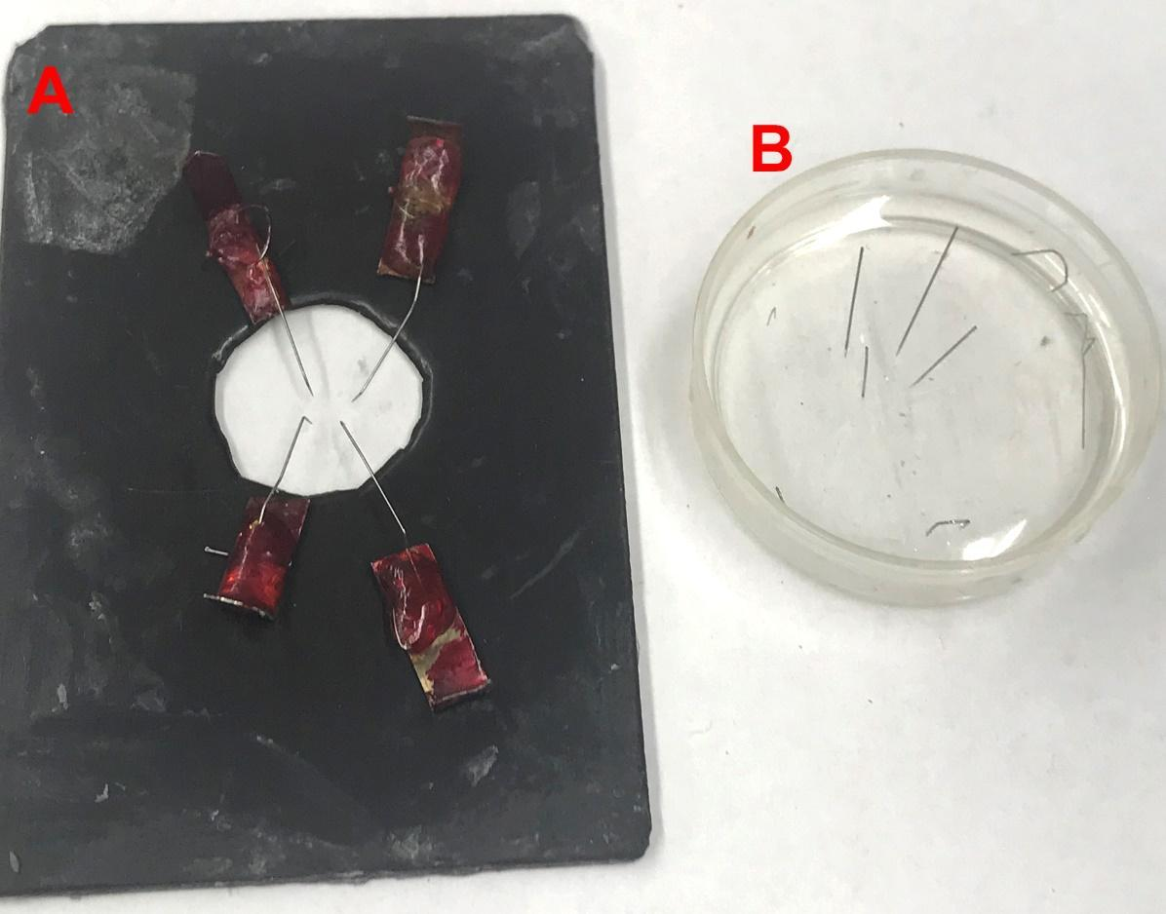
Figure 9: Larval Drosophila dissection dishes for exposing the heart. Glass slides with magnetic tape and mounted insect pins (A). Elastomer coated dish for fine insect pins to pin down the preparations (B).
2. To dissect the larvae it is best to wash any growth media off of them. This can be accomplished by bathing the larvae with fresh physiological saline. The larvae need to be pinned with the ventral side up so that a longitudinal slit can be made from the mouth hooks to the spiracles of the tracheal system at the caudal end. One has to be careful not to nick the heart tube in this process.
3. The intestines and salivary tissues can be removed gently. Very sharp # 5 tweezers are needed for this step. Flushing the preparation with fresh saline helps to remove the excess and loose tissue.
4. The dissection pins may need to be adjusted to elongate the dissected larvae and to spread out the caudal end in order to visualize the heart tube well.

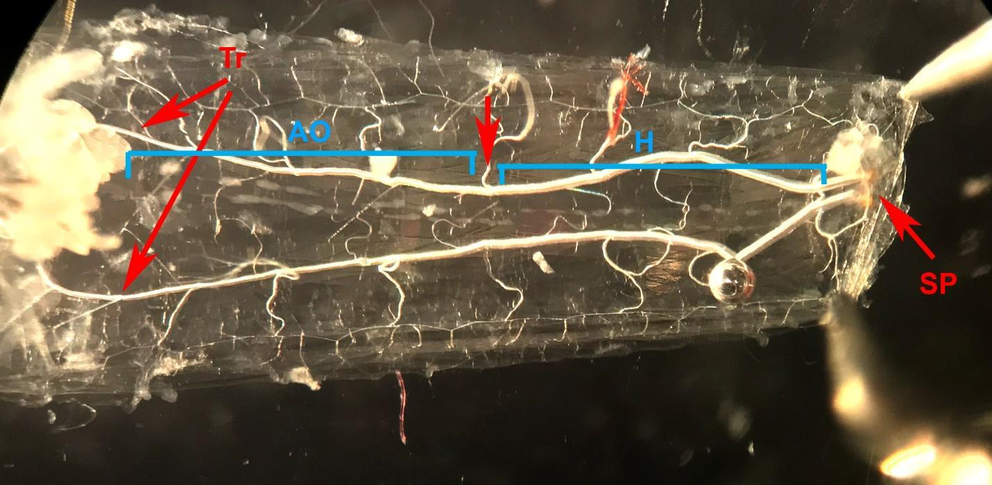
Figure 10: Larval heart tube in a 3rd instar. The animal is pinned with the dorsal side down. The heart tube is between the two trachea (Tr) running the length of the larvae. The spiracles (SP) are seen on the caudal end. The heart tube has the region of the true heart (H) where the heart generates the electrical rhythm and the aorta (AO) to direct hemolymph toward the head.
5. The contraction rate can be visually counted or a period of 30 seconds or a minute to then determine beats per minute.
6. The saline bath can be readily exchanged by using a wick constructed of tissue paper. The small piece of tissue paper twisted at one end to make a thin tip and to touch to the saline but not the preparation or pins. The saline containing the compound of interest can now be added to the preparation and the heartbeat for 30 seconds to a minute can be counted again. The counting can continue to take place at various time points as informed by the instructor.
7. Data can be graphed as raw values. A Sign pairwise test was used to analyze changes in heart rate after changing bath conditions or with exposure to light. Since some data sets may not be normally distributed (a number of zeroes in some groups) the non-parametric Sign test can be used. When appropriate, paired and unpaired t-tests (i.e., for percent changes as explained above) can be utilized.
Materials
Frogs
1. Adult, unsexed Northern leopard frogs (Lithobates pipiens) (Carolina Biological, Burlington, NC).
2. Approval by an Institutional Animal Care and Use Committee (IACUC)
3. A modified standard frog saline (Ringer’s solution) composed of (mM): NaCl 0.11, KCl 0.33, MgCl₂ 8.0, CaCl₂-2H₂O 1.1, Glucose 0.11 and HEPES 1.0. Saline is adjusted to a pH of 7.4 using NaOH.
4. Dissection dish with wax or elastomer (i.e., Sylgard) coated bottom
5. Dissection tools: Fine #5 tweezers, fine scissors, knife blade holder, #26002-20 insect pins (all obtained from Fine Science Tools (USA), Inc., 373-G Vintage Park Drive, Foster City, CA 94404-1139)
6. Beakers (to hold chemical solutions) and disposable plastic pipettes for exchanging solutions.
7. Electrical signals are recorded on line to a PowerLab 26T interface to a computer (ADInstruments, Colorado Springs, CO, USA). We use standard software from ADInstruments named Chart or Scope.
8. Bridge pod for the force transducer (different Bridge pods are required for different types of force transducers).
9. MLT0402 (2 grams) force transducer is the research grade as shown in the video. MLT 0210/D (10 mg-25 grams) and the MLT 500/A (0-500g) are the educational grades transducers (ADInstruments). This also depends on the size of the frogs or if toads are being used.
10. The compounds to be examined. In this case all saline chemicals and LPS were obtained from Sigma-Aldrich (St. Louis, MO, USA). The LPS should be dissolved in saline right before it is to be used.
11. Ring stand with clamps to mount the force transducer.

Drosophila
1. Dissection tools: Fine #5 tweezers and fine scissors (all obtained from Fine Science Tools (USA), Inc., 373-G Vintage Park Drive, Foster City, CA 94404-1139)
2. Dissecting microscope with zoom function for dissection and counting heart rate. (10X ocular objective and 4X zoom magnification)
3. Chemicals: All saline chemicals are obtained from Sigma chemical company (St. Louis, MO).
4. A modified HL3 saline was used to maintain the in situ hearts (NaCl 70 mM, KCl 5 mM, MgCl₂·6H₂O 20 mM, NaHCO₃ 10 mM, Trehalose 5 mM, sucrose 115 mM, BES buffer 25 mM, and CaCl₂·2H₂O 1 mM, pH 7.1) (de Castro et al., 2019)
5. The preparation dish consisted of a glass slide (VWR) with magnetic tape (Best Buys retail out-let) adhered to one side. A hole in the center of the magnetic strip allows the preparation to be viewed with transmitted light. Dissecting pins (Fine Scientific Tools, WA) are bent and glued to paper clips. The paper clips are easily maneuvered on the magnetic tape to hold the filleted preparation in place. This type of recording dish has been previously described for utilization of pinning ganglia isolated from the leech ventral nerve cord (Muller et al., 1981) and for larval Drosophila (Cooper et al., 2009). If the elastomer dish is to be used then a small Petri dish filled with about 5 to 10 mm of hardened elastomer and fine insect pins (Fine Science Tools, Inc catalog # 26001-60)
6. Beakers (to hold chemical solutions) and disposable plastic pipettes for exchanging solutions.
Cited References
Akasaka T, Ocorr K. 2009. Drug discovery through functional screening in the Drosophila heart. Methods in molecular biology 577:235–249. doi:10.1007/978-1-60761-232-2_18
Al-Nassan S, Fujino H. 2018. Exercise preconditioning attenuates atrophic mediators and preserves muscle mass in acute sepsis. General Physiology and Biophysics 37(4):433-441. doi: 10.4149/gpb_2018001.
Anderson RH., Mori S, Spicer D E, Sanchez-Quintana D, Jensen B. 2018. The anatomy, development, and evolution of the atrioventricular conduction axis. Journal of cardiovascular development and disease. 5(3):44. doi:10.3390/jcdd5030044
Andrä J, Garidel P, Majerle A, Jerala R, Ridge R, Paus E, Novitsky T, Koch MHJ, Brandendurg K. 2004. Biophysical characterization of the interaction of Limulus polyphemus endotoxin neutralizing protein with lipopolysaccharide. European Journal of Biochemistry 271:2037–2046.
Anyagaligbo O, Bernard J, Greenhalgh A, Cooper RL. 2019. The effects of bacterial endotoxin (LPS) on cardiac function in a medicinal blow fly (Phaenicia sericata) and a fruit fly (Drosophila melanogaster). Comparative Biochemistry and Physiology C 217:15–24.

Bodmer R. 1993. The gene tinman is required for specification of the heart and visceral muscles in Drosophila. Development 118(3):719-729.
Bodmer W. 1995. Where will genome analysis lead us forty years on? Annals of the New York Academy of Sciences 758:414–426.
Carl MA, Ndao IM, Springman AC, Manning SD, Johnson JR, Johnston BD, Burnham CA, Weinstock ES, Weinstock GM, Wylie TN, Mitreva M, Abubucker S, Zhou Y, Stevens HJ, Hall-Moore C, Julian S, Shaikh N, Warner BB, Tarr PI. 2014. Sepsis from the gut: the enteric habitat of bacteria that cause late-onset neonatal bloodstream infections. Clinical Infectious Diseases 58(9):1211-1218. doi: 10.1093/cid/ciu084.

Cimolai MC, Alvarez S, Bode C, Bugger H. 2015. Mitochondrial mechanisms in septic cardiomyopathy. International Journal of Molecular Sciences 16:17763‑17778.

Cooper RL, McNabb M, Nadolski J. 2019. The effects of a bacterial endotoxin LPS on synaptic transmission at the neuromuscular junction. Heliyon- Elsevier 5:e01430

Cooper AS, Rymond KE, Ward MA, Bocook EL, Cooper RL. 2009. Monitoring heart function in larval Drosophila melanogaster for physiological studies. Journal of Visualized Experiments 33:e1596

Coscia M, Giacomelli S, Oreste U. 2011. Toll-like receptors: an overview from invertebrates to vertebrates. Invertebrate Survival Journal 8:210-226.

Cripps RM, Olson EN. 2002. Control of cardiac development by an evolutionarily conserved transcriptional network. Developmental Biology 246(1):14–28

Dasari S, Cooper RL. 2006. Direct influence of serotonin on the larval heart of Drosophila melanogaster. Journal of Comparative Physiology B 176:349–357.

de Castro C, Titlow J, Majeed ZR, Cooper RL. 2014. Analysis of various physiological salines for heart rate, CNS function, and synaptic transmission at neuromuscular junctions in Drosophila melanogaster larvae. Journal of Comparative Physiology A 200:83–92, DOI 10.1007/s00359-013-0864-0,

Eidelman LA, Putterman D, Putterman C, Sprung CL. 1996. The spectrum of septic encephalopathy definitions, etiologies, and mortalities. Journal of American Medical Association 275(6):470–473.

Friedman AH. 1971. Circumstances influencing Otto Loewi's discovery of chemical transmission in the nervous system. Pflugers Archive 325:85–86.
Friedrich O, Reid MB, Van den Berghe G, Vanhorebeek I, Hermans G, Rich MM, Larsson L. 2015. The sick and the weak: Neuropathies/myopathies in the critically ill. Physiological Reviews 95(3):1025-1109. doi: 10.1152/physrev.00028.2014.

Gao M, Wang X, Zhang X, Ha T, Ma H, Liu L, Kalbfleisch JH, Gao X, Kao RL, Williams DL, Li C. 2015. Attenuation of cardiac dysfunction in polymicrobial sepsis by MicroRNA‑ 146a is mediated via targeting of IRA K1 and TRA F6 expression. Journal of Immunology 195:672‑682.
Gu GG, Singh S. 1995. Pharmacological analysis of heartbeat in Drosophila. Journal of Neurobiology 28:269–280.
Istas O, Greenhalgh A, Cooper RL. 2019. The Effects of a Bacterial Endotoxin on Behavior and Sensory-CNS-Motor Circuits in Drosophila melanogaster. Insects 10:115. https://doi.org/10.3390/insects10040115

Kim SB, Jeon YD, Kim JH, Kim JK, Ann HW, Choi H, Kim MH, Song JE, Ahn JY, Jeong SJ, Ku NS, Han SH, Choi JY, Song YG, Kim JM. 2015. Risk factors for mortality in patients with Serratia marcescens bacteremia. Yonsei Medical Journal 56(2):348-354. doi: 10.3349/ymj.2015.56.2.348.

Kleino A, Silverman N. 2014. The Drosophila IMD pathway in the activation of the humoral immune response. Developmental and Comparative Immunology 42(1):25–35. doi:10.1016/j.dci.2013.05.014
Lehmacher C, Abeln B, Paululat A. 2012. The ultrastructure of Drosophila heart cells. Arthropod Structure and Development 41(5):459–474. doi:10.1016/j.asd.2012.02.002
Levin TC, Malik HS. 2017. Rapidly evolving Toll-3/4 genes encode male-specific Toll-like receptors in Drosophila. Molecular Biology and Evolution 34(9):2307-2323. doi: 10.1093/molbev/msx168.

Linhartová I, Bumba L, Mašín J, Basler M, Osička R, Kamanová J, Procházková K, Adkins I, Hejnová-Holubová J, Sadílková L, Morová J, Sebo P. 2010. RTX proteins: A highly diverse family secreted by a common mechanism. FEMS Microbiology Reviews 34(6):1076–1112. doi:10.1111/j.1574-6976.2010.00231.x

Liu YC, Yu MM, Shou ST, Chai YF. 2017. Sepsis‑induced cardiomyopathy: Mechanisms and treatments. Frontiers in Immunology 8:1021. doi: 10.3389/fimmu.2017.01021.
Loewi O. 1921. Über humorale Übertragbarkeit der Herznervenwirkung. I.. Pflügers Archive 189:239–242. doi:10.1007/BF01731235.
Loker ES, Adema CM, Zhang SM, Kepler TB. 2004. Invertebrate immune systems--not homogeneous, not simple, not well understood. Immunological Reviews 198:10–24. doi:10.1111/j.0105-2896.2004.0117.x
Lorenzon S, de Guarrini S, Smith V, Ferrero E. 1999. Effects of LPS injection on circulating haemocytes in crustaceans in vivo. Fish & Shellfish Immunology 9:31-50. doi: 10.1006/fsim.1998.0168.
Miller DJ. 2004. Sydney Ringer; physiological saline, calcium and the contraction of the heart. The Journal of Physiology 555(3):585–587. doi:10.1113/jphysiol.2004.060731
Monahan-Earley R, Dvorak AM, Aird WC. 2013. Evolutionary origins of the blood vascular system and endothelium. Journal of Thrombosis and Haemostasis 11(Suppl 1):46–66. doi:10.1111/jth.12253
Muller KJ, Nicholls JG, Stent GS. 1981. Neurobiology of the Leech. Cold Spring Harbor Laboratory. Cold Spring Harbor, New York. Pp. 254.
Na J, Musselman Lp, Pendse J, Baranski TJ, Bodmer R, Ocorr K, Cagan R. 2013. A Drosophila model of high sugar diet-induced cardiomyopathy. PloS Genetics 9(1):e1003175. doi:10.1371/journal.pgen.1003175
Nishimura M, Ocorr K, Bodmer R, Cartry J. 2011. Drosophila as a model to study cardiac aging. Experimental Gerontology 46(5):326–330. doi:10.1016/j.exger.2010.11.035
Novitsky TJ. 1994. Limulus amebocyte lysate (LAL) detection of endotoxin in human blood. Journal of Endotoxin Research 1:253–263
Ono N, Yamaguchi T, Ishikawa H, Arakawa M, Takahashi N, Saikawa T, Shimada T. 2009. Morphological varieties of the Purkinje fiber network in mammalian hearts, as revealed by light and electron microscopy. Archives of Histology and Cytology72(3):139-149.
Palavutitotai N, Jitmuang A, Tongsai S, Kiratisin P, Angkasekwinai N. 2018. Epidemiology and risk factors of extensively drug-resistant Pseudomonas aeruginosa infections. PLoS One 13(2):e0193431. doi:10.1371/journal.pone.0193431.

Pien BC, Sundaram P, Raoof N, Costa SF, Mirrett S, Woods CW, Reller LB, Weinstein MP. 2010. The clinical and prognostic importance of positive blood cultures in adults. American Journal of Medicine 123(9):819-828. doi: 10.1016/j.amjmed.2010.03.021.

Purkinje J. 1845. Mikroskopisch-neurologische Beobachtungen. Archiv für Anatomie, Physiologie und Wissenschaftliche Medicin 12:281-295.
Rizki T. 1978. The circulatory system and associated tissues. In: Ashburner M, Wright T (eds) The genetics and biology of Drosophila. Academic, London, pp 397–452.
Rotstein B, Paululat A. 2016. On the morphology of the Drosophila Heart. Journal of Cardiovascular Development and Disease 3(2):15. doi:10.3390/jcdd3020015
Shashikumar SP, Stanley MD, Sadiq I, Li Q, Holder A, Clifford GD, Nemati S. 2017. Early sepsis detection in critical care patients using multiscale blood pressure and heart rate dynamics. Journal of Electrocardiology 50(6):739-743. doi: 10.1016/j.jelectrocard.2017.08.013.
Steiner H. 2004. Peptidoglycan recognition proteins: On and off switches for innate immunity. Immunological Reviews 198:83-96.

Tong DM, Zhou YT. 2017. No awakening in supratentorial intracerebral hemorrhage is potentially caused by sepsis-associated encephalopathy. Medical Science Monitor23:4408-4414.

US Department Health and Human Services. 1987. Guideline on the validation of the Limulus amebocyte lysate test as an end-product endotoxin test for human and animal parenteral drugs, biological products, and medical devices. Accessed on Dec. 26, 2019 http://citeseerx.ist.psu.edu/viewdoc/download;jsessionid=3A346C6757AD03CB41B6DA54067C9648?doi=10.1.1.178.656&rep=rep1&type=pdf
Victor S, Nayak VM. 2000. Evolutionary anticipation of the human heart. Annals of the Royal College of Surgeons of England 82(5):297–302.
Walley KR. 2018. Sepsis‑induced myocardial dysfunction. Current Opinion in Critical Care 24:292‑299.

Wang Z, Bu L, Yang P, Feng S, Xu F. 2019. Alleviation of sepsis‑induced cardiac dysfunction by overexpression of Sestrin2 is associated with inhibition of p‑S6K and activation of the p‑AMPK pathway. Molecular Medicine Reports 20(3):2511-2518. doi: 10.3892/mmr.2019.10520.
Wessells RJ, Bodmer R. 2004. Screening assays for heart function mutants in Drosophila. Biotechniques 37:58–60.
Wilson JX, Young GB. 2003. Progress in clinical neurosciences: Sepsis-associated encephalopathy: Evolving concepts. Canadian Journal of Neurological Sciences 30(2): 98–105.

Yoshida H, Kinoshita K, Ashida M. 1996. Purification of a peptidoglycan recognition protein from hemolymph of the silkworm, Bombyx mori. Journal of Biological Chemistry 271:13854-13860.

Notes for the Instructor
This report is primarily a teaching tool for advanced undergraduate students in physiology courses that participate in experimentation. The significance as well as the potential mechanism behind how the heart functions can be addressed by the students. The frog preparation is amenable to student laboratories in physiology and for demonstrating pharmacological concepts to students. This preparation has been in use for over 100 years, and it still offers much as a model for investigating the generation and regulation of pacemaker rhythms and for describing the mechanisms underlying their modulation. This robust preparation is well suited to training students in physiology and pharmacology. The students will also learn to present data in graphical form for statistical analysis. The frog heart is very easy to expose with minimal dissection and the contractions are easy to record. However, pithing the frog might be best performed by staff in a preparation room not visible to students as this can sometimes be a bit unnerving
The exposed frog heart is readily able to be examined to the effects of exogenous substances or even as the classical laboratory experiments to vagal nerve stimulation. The alteration in peristaltic activity can be monitored visually or with a force transducer, which can also monitor the rate and force of contractions. Because of its simplicity and reliability as a bioassay preparation, the frog heart is still very useful for investigating many research questions about the mechanisms of the function of the pacemaker cells, electrical conduction, muscle contraction, and receptor function. The frog heart is also useful for testing various factors related to the direct effects of different LPS strains, as well as the many downstream compounds (i.e. cytokines) involved in septicemia. A number of wet lab experiments using the frog heart, or even the turtle heart, use a standard approach of vagal nerve stimulation with or without the use of muscarinic agonists and antagonists as well as sympathomimetic drugs. These classic physiology teaching lab experiments can be tweaked with the addition of examining the effects of the various bacterial endotoxins.
A novel twist in standard physiology laboratory teaching exercises in the use of insects or invertebrates to address cardiac function. Crayfish and crabs are easy to use for monitoring heart rate in the intact functioning animal (insects- Bellen et al., 2010 and Bier and Bodmer, 2004; crayfish-Bierbower and Cooper, 2009; crabs- Wycoff et al., 2018). Injection of LPS (Saelinger et al., 2019) or other substances such as serotonin or dopamine (Listerman et al., 2000) can also be performed. Injecting compounds into the intact animal will likely have an effect on various physiological systems, such as ventilation rate (Schapker et al., 2002; Shuranova et al., 2003) and not just the heart. Addressing how compounds might also have an effect on the autonomic nervous system in crustacean can be addressed as a comparative exercise in the autonomic nervous system of different animals (Choma et al., 2011; Shuranova et al., 2006). Annelids (i.e., worms and leeches) are also able to be used with exposed hearts for direct application of compounds (Bohrer 2006; Halfmann and Crisp, 2011; Stent et al., 1979).
If these experimental labs are to be performed each year or semester small variations can be implemented such as a different concentration of a substance or different strains of LPS, as there are many. At some point in time, it would be nice to report the effects of the various modifications so it may add to the scientific literature. By tweaking the procedure with varied compounds the lab reports will not as likely be shared from student to student over the years as well.
One may also have students engage in related history to various topics, such as to the development of saline that keeps the frog heart alive which led to the saline used today in Human IV bags (i.e Ringers, saline). Amazingly, the key component of the use of Ca2+ ions was serendipitously discovered to be important back in the 1880’s (Miller 2004). Only recently has a saline been developed which maintains the larval Drosophila heart to keep beating upon exposing to an in situ heart (deCastro et al., 2014, 2019). The discovery of the chemical released by Vagal nerve stimulation (Vagusstoff) in the 1921which reduced heart rate in frogs lead to the understanding of autonomic nervous system control of the mammalian heart (Loewi 1921; Friedman 1971).
If students show an interest in the comparative response to bacterial strains or even just the response to LPS from gram-negative bacteria they might be surprised that plants as well as animals have to defend themselves from bacterial infection while also having a mutualistic relationship with some strains of bacteria. In defense of bacteria, invertebrates use innate immune processes while amphibians and mammals use an innate as well as adaptive immune system. Even though invertebrates use an innate immune response it can be complex (Loker et al., 2004). The innate immune system will promote rapid aggregation of the bacteria and related endotoxins (Lorenzon et al., 1999). In fact, the blood (i.e., hemolymph) of the horseshoe crab has been used for many years to test for the presence of gram-negative bacteria related to human health care by the Limulus amebocyte lysate assay (Andrä et al., 2004; Novitsky 1994; US Department Health and Human Services, 1987).

Preparing students for conducting these exercises could be approached by having the students completing the take-home lessons first if one feels the participants might need a more in-depth understanding before conducting the wet lab procedures. The set of questions and assignments could even be performed as open response questions as a pre-lab assessment tool and repeated after the students have performed the laboratory exercise and researched the literature as a post-exercise assessment tool.
A post survey was administered to students as extra credit to learn their perspectives on the laboratory. The post survey asked students to respond to four question to ascertain what they believed was (1) helpful about the laboratory, (2) surprising about the laboratory, (3) challenging, and (4) how they overcame the challenges. Seventy-two students agreed to share their responses with the researchers collecting the data. A summary of the most frequently occurring responses by category and then by response is illustrated in Table 1 for questions 1-3.

The aspects of the laboratory students found most helpful focused on conducting the experiment rather than learning about the physiological processes through readings and observing models. They were able to learn how to use instruments, following protocols, and collecting data through the experience. Several specifically noted how making observations of the beating frog heat helped them better understand that anatomy and function of the heart rather than trying to make sense of its function from static images and readings. The laboratory write-up also promoted sense-making about the anatomy and physiology of the frog heart and larval heart tube and how LPS affected cardiology in the two models.
Table 1.

Summary of Aspects of the Laboratory Students Found Most Helpful, Their Surprises, and Challenges.

Survey Question | Frequent Responses by Category | Frequency
What aspects of the laboratory were most helpful? (n = 89 responses) | Carrying out the experiment (obs., hands-on) | 45
 | Scaffolding (I.e., instructors & TAs) | 11
 | Making observations of the beating heart/heart tube | 21
 | Sense-making to explain results | 7
What surprised you?  (n = 72 responses) | Findings | 30
 | Findings did not match hypothesis | 10
 | Found no significant difference | 19
 | Observing frog heart beating /Drosophila larval heart tube beating | 18
What challenges did you experience? (n = 88 responses) | Lab protocol | 30
 | Unclear protocol | 15
 | Set up (i.e., force transducer, orienting frog) & frog dissection | 12
 | Data collection | 24
 | Computer crashing | 5
 | Measuring heart rate, particularly in Drosophila larva | 18

The surprises students most often cited related directly to observing live organisms in the experiment. They most often reported being amazed to see the beating frog heart and Drosophila heart tube since many of them had not seen a live heart beating before, whereas other students had never dissected an organism before. They also were surprised that their hypothesis that LPS would affect the heart rate was not supported by the data collected across the four laboratory sections. The incongruence between their hypothesis and the findings also created challenges for some students as they tried to make sense of the class findings when they believed they had observed a change in the heart rate of the frog when their unknown substance was applied. They also noted challenges in setting up the lab, including dissecting the frog, inserting the hook in the heart, and setting up the force transducer. Other challenges included one or two computers that crashed during the data collection and difficulty measuring the heart rate, particularly for the Drosophila larva because of the small size of the heart tube and the sporadic rhythm. Partners bumping the table during data collection also made observing the heart tube difficult. The support of the TAs and the instructors were essential in helping students work through the protocol.

Cited References
Andrä J, Garidel P, Majerle A, Jerala R, Ridge R, Paus E, Novitsky T, Koch MH, Brandenburg K. 2004. Biophysical characterization of the interaction of Limulus polyphemus endotoxin neutralizing protein with lipopolysaccharide. European Journal of Biochemistry 271(10):2037-2046.

Bakshi A, Patrick LE, Wischusen EW. 2016. A framework for implementing course-based undergraduate research experiences (CUREs) in freshman biology labs. The American Biology Teacher 78(6):448–455.

Bellen HJ, Tong C, Tsuda H. 2010. 100 years of Drosophila research and its impact on vertebrate neuroscience: A history lesson for the future. Nature Review Neuroscience 11:514–522.

Bier E, Bodmer R. 2004. Drosophila, an emerging model for cardiac disease. Gene 342:1–11.

Bierbower SM, Cooper RL. 2009. Measures of heart and ventilatory rates in freely moving crayfish. Journal of Visualized Experiments (JoVE) 32: http://www.jove.com/index/details.stp?id=1594 doi:10.3791/1594.

Bohrer KE. 2006. Effects of drugs on pulsation rate of Lumbriculus variegatus (blackworms). In Tested Studies for Laboratory Teaching (MA O'Donnell, Editor). Proceedings of the 27th Workshop/Conference of the Association for Biology Laboratory Education (ABLE) 27:127-146.

Choma MA, Suter MJ, Vakoc BJ, Bouma BE, Tearney GJ. 2011. Physiological homology between Drosophila melanogaster and vertebrate cardiovascular systems. Disease models and mechanisms 4:411–420.

de Castro C, Titlow J, Majeed ZR, Cooper RL 2014. Analysis of various physiological salines for heart rate, CNS function, and synaptic transmission at neuromuscular junctions in Drosophila melanogaster larvae. Journal of comparative physiology. A, Neuroethology, sensory, neural, and behavioral physiology 2200(1):83-92.

de Castro C, Titlow JS, Majeed ZR, Malloy C, King KE, Cooper RL. 2019. Chemical and mechanical factors required for maintaining cardiac rhythm in Drosophila melanogaster larva. Journal of Entomology 16 (2):62-73.

Esparza, D., A. E. Wagler, and J. T. Olimpo. 2020. Characterization of Instructor and Student Behaviors in CURE and Non-CURE Learning Environments: Impacts on Student Motivation, Science Identity, Development, and Perceptions of the Laboratory Experience. CBE Life Sciences Education 19: 1-15.

Friedman WF 1971. Congenital heart disease--clinical features and pathophysiology. Current problems in pediatrics 1(3):3-63.

Halfmann K, Crisp K. 2011. A kinematic study of pulsation in the dorsal blood vessel of the blackworm, Lumbriculus variegatus. IMPULSE. https://impulse.appstate.edu/articles/2011/kinematic-study-pulsation-dorsal-blood-vessel-blackworm-lumbriculus-variegatus

Henige, K. 2011. Undergraduate student attitudes and perceptions toward low- and high-level inquiry exercise physiology teaching laboratory experiences. Advances in Physiology Education 35: 197-205.

Linn MC, Palmer E, Baranger A, Gerard E, Stone E. 2015. Undergraduate research experiences: Impacts and opportunities. Science 347:1261757.

Listerman L, Deskins J, Bradacs H, Cooper RL. 2000. Measures of heart rate during social interactions in crayfish and effects of 5-HT. Comparative Biochemistry and Physiology A. 125:251-264

Loker ES, Adema CM, Zhang SM, Kepler TB 2004. Invertebrate immune systems--not homogeneous, not simple, not well understood. Immunological reviews 198:10-24.

Loewi O 1921. "Über humorale Übertragbarkeit der Herznervenwirkung. I.". Pflügers Archive 189: 239–242.

Lorenzon S, de Guarrini S, Smith VJ, Ferrero EA 1999. Effects of LPS injection on circulating haemocytes in crustaceansin vivo, Fish & Shellfish Immunology 9(1):31-50,

Malloy C, DayaramV, Martha S, Alvarez B, Chukwudolue I, Dabbain N, D.mahmood D, Goleva S, Hickey T, Ho A, King M, Kington P, Mattingly M, Potter S, Simpson L, Spence A, Uradu H, Van Doorn JL, Weineck K, Cooper RL. 2017. The effects of neighboring muscle injury on proprioception responses in crayfish and crab. Journal of Experimental Zoology 327(6):366–379.

Makarevitch, I., C. Frechette, and N. Wiatros. 2015. Authentic Research Experience and “Big Data” Analysis in the Classroom: Maize Responses to Abiotic Stress. CBE Life Sciences Education 14: 1-12.

Miller DJ 2004. Sydney Ringer; physiological saline, calcium and the contraction of the heart. Journal of Physiology 555(3):585-587.

Novitsky TJ 1994. Limulus amebocyte lysate (LAL) detection of endotoxin in human blood.
Journal of Endotoxin Research 1(4):253-263

Saelinger CM, McNabb MC, McNair R, Bierbower S, Cooper RL. 2019. Effects of bacterial endotoxin (LPS) on the cardiac function, neuromuscular transmission and sensory-CNS-motor nerve circuit: A crustacean model Comparative Biochemistry and Physiology A 237:110557.

Schapker H, Breithaupt T, Shuranova Z, Burmistrov Y, Cooper RL. 2002. Heart rate and ventilatory correlative measures in crayfish during environmental disturbances & social interactions. Comparative Biochemistry and Physiology A 131:397-407.

Shuranova ZP, Burmistrov YM, Cooper RL. 2003. Activity of the ventilatory muscles in the crayfish. Comparative Biochemistry and Physiology A 134:461-469

Shuranova ZP, Burmistrov YM, Strawn JR, Cooper RL. 2006. Evidence for an autonomic nervous system in decapod crustaceans. International Journal of Zoological Research 2(3):242-283.

Stanback M, Stanback AE, Akhtar S, Basham R, Chithrala B, Collis B, Heberle BA, Higgins E, Lane A, Marella S, Ponder M, Raichur P, Silverstein A, Stanley C, Vela K, Cooper RL. 2019. The effect of lipopolysaccharides on primary sensory neurons in crustacean models. IMPLUSE https://impulse.appstate.edu/articles/2019/effect-lipopolysaccharides-primary-sensory-neurons-crustacean-models

Staub, N. L., M. Poxleitner, A. Braley, H. Smith-Flores, C. M. Pribbenow, L. Jaworski, D. Lopatto, and K. R. Anders. 2016. Scaling Up: Adapting a Phage-Hunting Course to Increase Participation of First-Year Students in Research. CBE Life Sciences Education 15: 1-11.

Stent GS, Thompson WJ, Calabrese RL. 1979 Neural control of heartbeat in the leech and in some other invertebrates Physiological Reviews 59:101-136.

Swanson, H. I., O. P. Sarge, T. Rodrigo-Peiris, L. Xiang, and V. M. Cassone. Development of a Course-Based Undergraduate Research Experience to Introduce Drug-Receptor Concepts. Journal of Medical Education and Curricular Development 3:57-66.

Thenappan A, Dupont-Versteegden EE, Cooper RL. 2019. An educational model for understanding acute deep tissue injury of motor units. Journal of Young Investigators 36(5):62-71.

US Department Health and Human Services 1987. Guideline on the validation of the Limulus amebocyte lysate test as an end-product endotoxin test for human and animal parenteral drugs, biological products, and medical devices

Wycoff S, Weineck K, Conlin S, Grau E, Bradley A, Cantrell D, Eversole S, Grachen C, Hall K, Hawthorne D, Kinmon C, Ortiz Guerrero P, Patel B, Samuels K, Suryadevara C, Valdes G, Ray A, Fleckenstein L, Piana E, Cooper RL. 2018. Investigating potential effects of clove oil (eugenol) in model crustaceans. IMPLUSE 1-21 https://impulse.appstate.edu/articles/2018/effects-clove-oil-eugenol-proprioceptive-neurons-heart-rate-and-behavior-model-crustac

Acknowledgments
Funded by Department of Biology, University of Kentucky for laboratory supplies and personal funds of Robin Cooper for attending ABLE and presenting the module.
About the Authors
Jate Bernard is a medical student at the University of Kentucky. He received a B.S. in Chemistry from the University of Virginia.
Melody Danley is an instructor of animal physiology and general biology at the University of Kentucky. She earned a B.S. in Wildlife Resources from U.C. Davis in 1998. She also earned both a M.S. and a Ph.D. in Forest Resource Sciences from West Virginia University in 2002 and 2008, respectively. She has been teaching at the University of Kentucky since 2010.
Katherine Sharp earned a B.S. in Biology from Stephens College in 2015 and an M.S. in Chemistry and Biochemistry from the University of Oklahoma in 2018. Her prior research experience includes working with healthcare-acquired pathogens, such as Pseudomonas aeruginosa, and studying biological mechanisms that are implicated in chronic infections. She is currently working towards a Ph.D. in STEM Education at the University of Kentucky. Her current research interests include creating authentic learning experiences in university biochemistry classrooms and determining the impact of critical thinking skills in undergraduate biochemistry through authentic learning experiences within the context of bacterial infection and antibiotic resistance.
Rebecca Krall earned an undergraduate degree in elementary education from Virginia Tech in 1988, certified in science and literacy in grades K-8. After teaching science in grades six through eight, she earned a masters and doctorate in science education from the University of Virginia. She currently teaches science methods and effective uses of technology at the University of Kentucky. Her current research interests include developing K-8 teachers’ scientific knowledge and pedagogy for creating authentic science experiences for students, the effect on student learning, and teachers’ abilities to notice, interpret, and apply student thinking during their instruction.
Robin Cooper is an instructor of animal physiology and neurophysiology at the University of Kentucky. He received a double major with a B.S. from Texas Tech in 1983 and a PhD in Physiology from Texas Tech Medical School in 1989. He has been at the University of Kentucky since 1996.

